51 How can I improve my communication skills in a professional setting? Please highlight the important words to the semantic meanings in every sentence using boldface fonts.

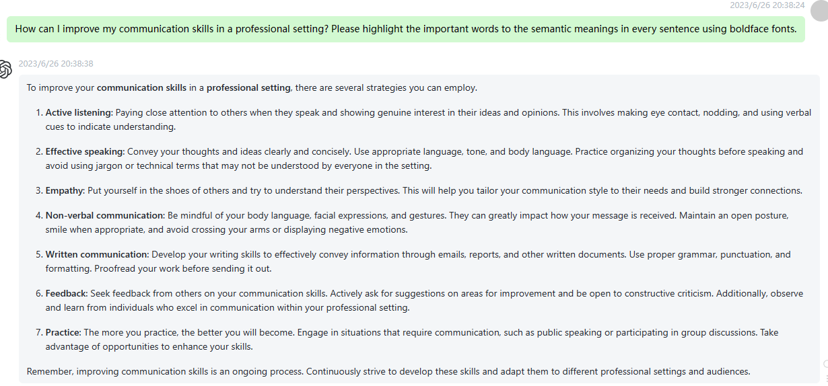

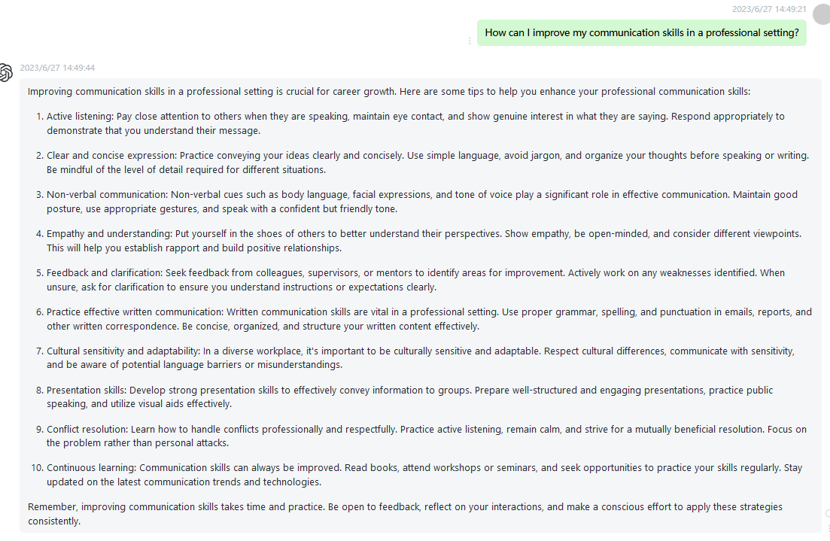

52 What are the key factors to consider when starting a small business? Please highlight the important words to the semantic meanings in every sentence using boldface fonts.

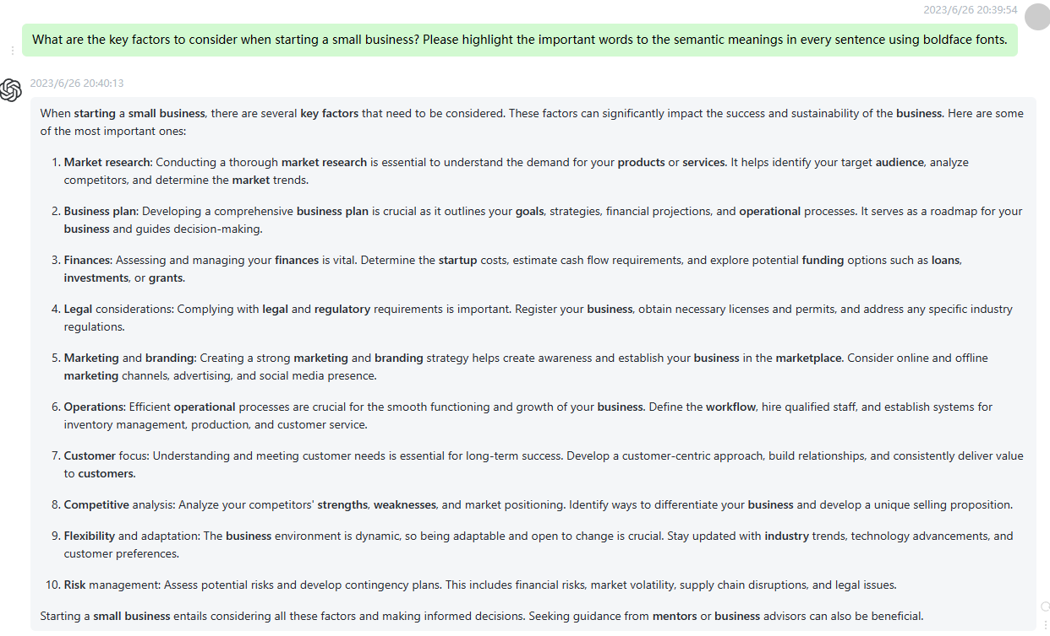

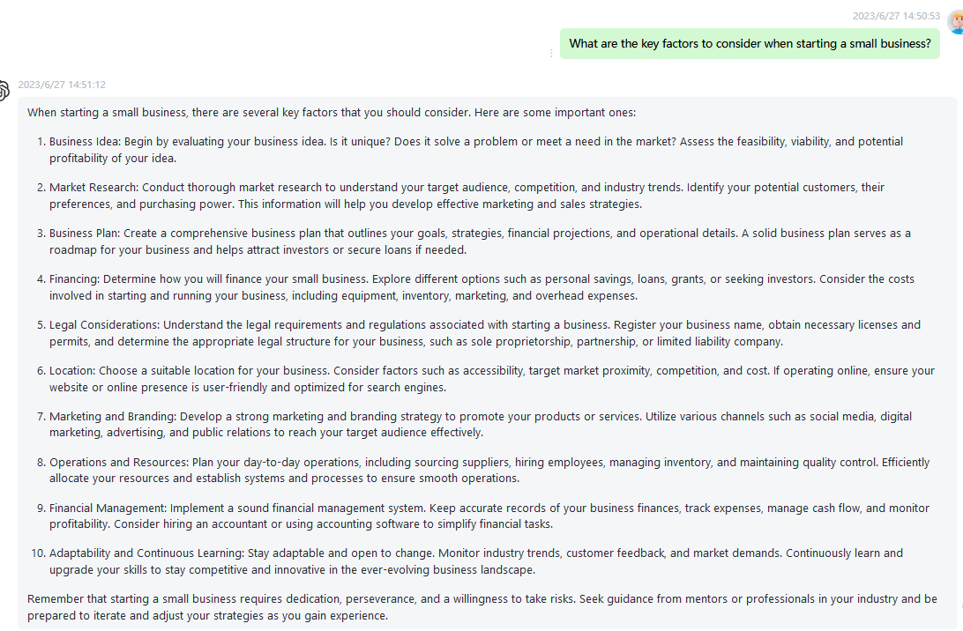

53 How can I enhance my time management skills and increase productivity? Please highlight the important words to the semantic meanings in every sentence using boldface fonts.

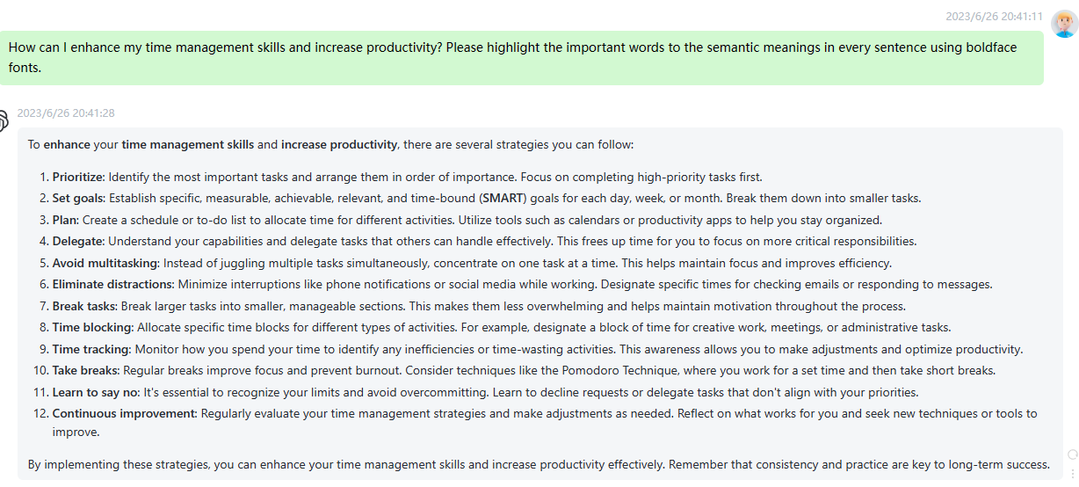

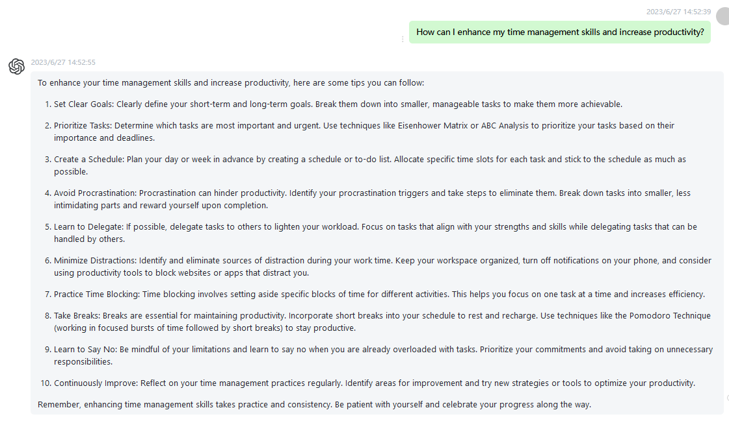

54 What are some effective strategies for conflict resolution in personal relationships? Please highlight the important words to the semantic meanings in every sentence using boldface fonts.

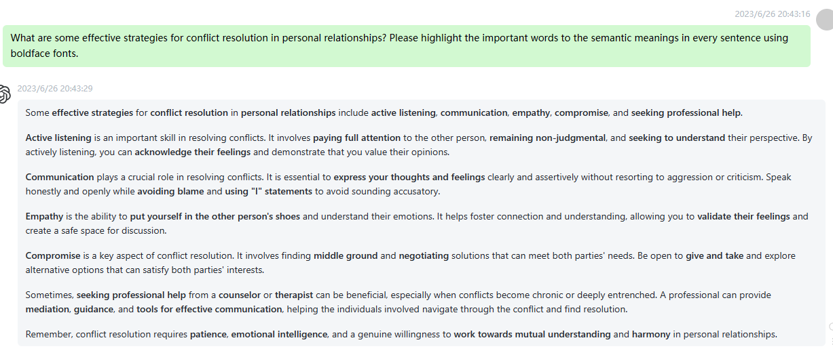

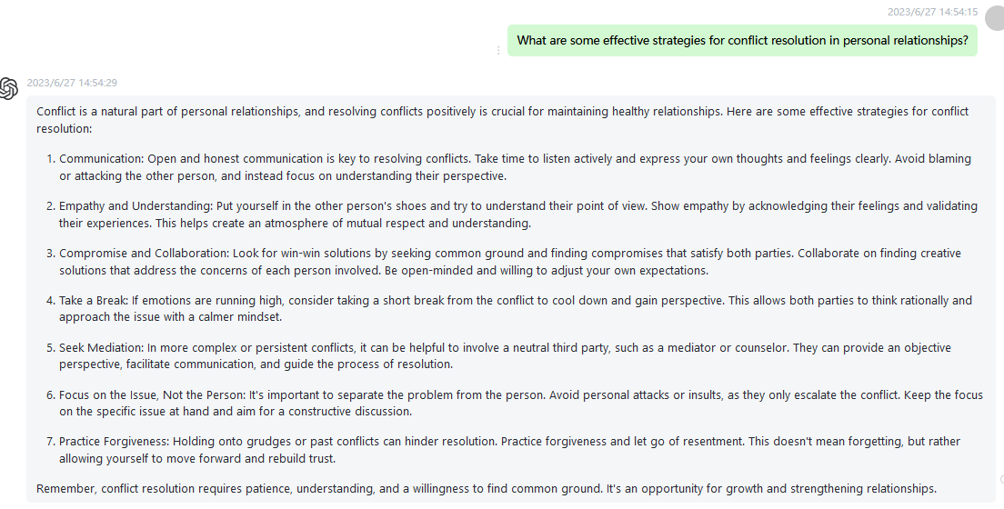

55 How can I develop and maintain a healthy work-life balance? Please highlight the important words to the semantic meanings in every sentence using boldface fonts.

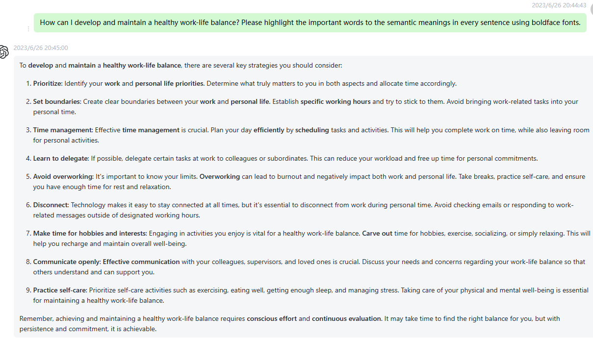

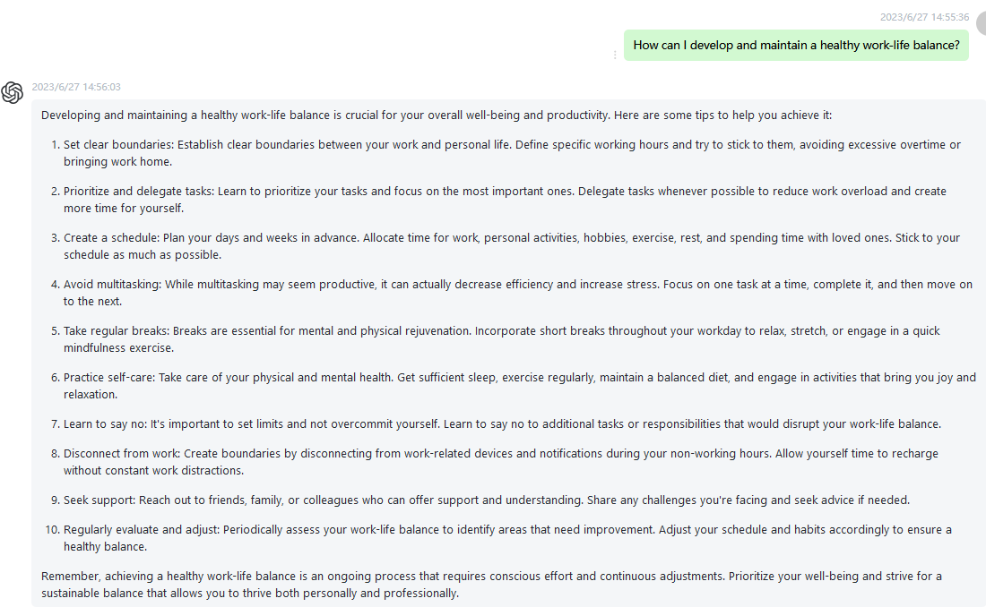

56 What are the benefits of mindfulness practices and how can I incorporate them into my daily life? Please highlight the important words to the semantic meanings in every sentence using boldface fonts.

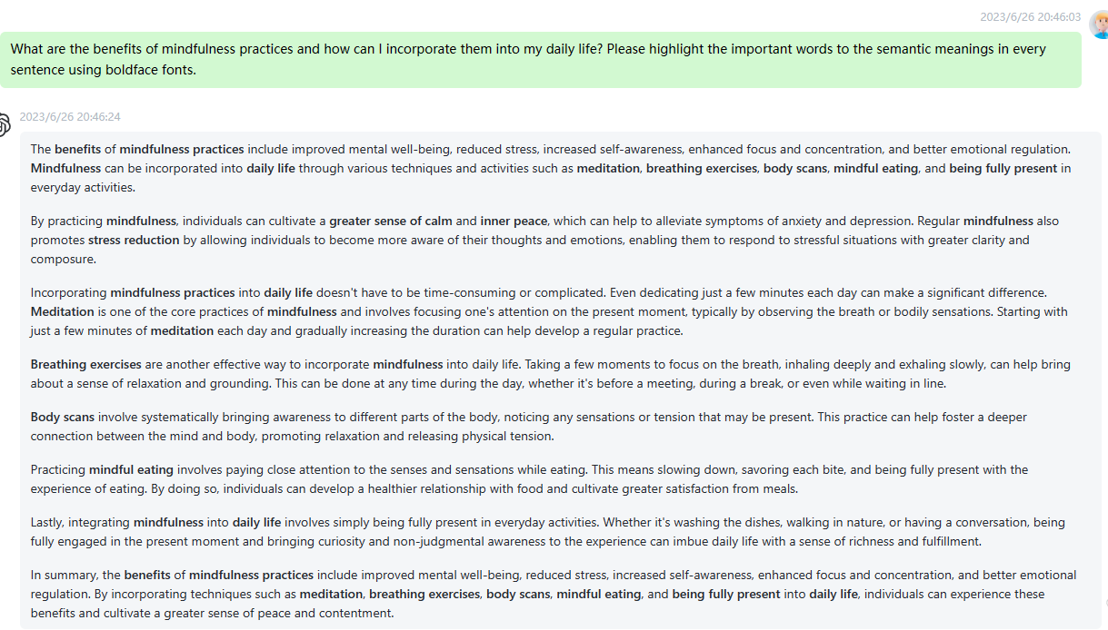

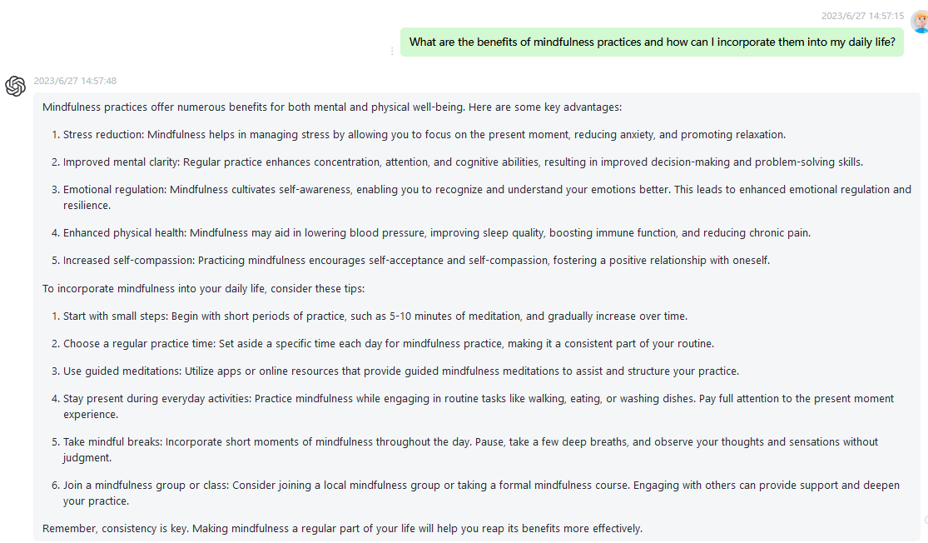

57 How can I build a strong personal brand for career advancement? Please highlight the important words to the semantic meanings in every sentence using boldface fonts.

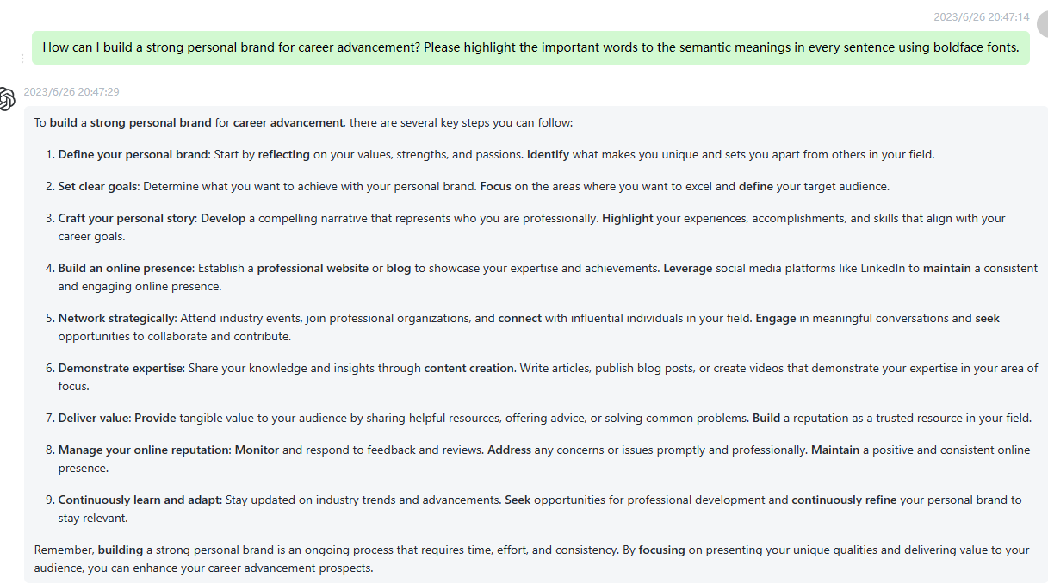

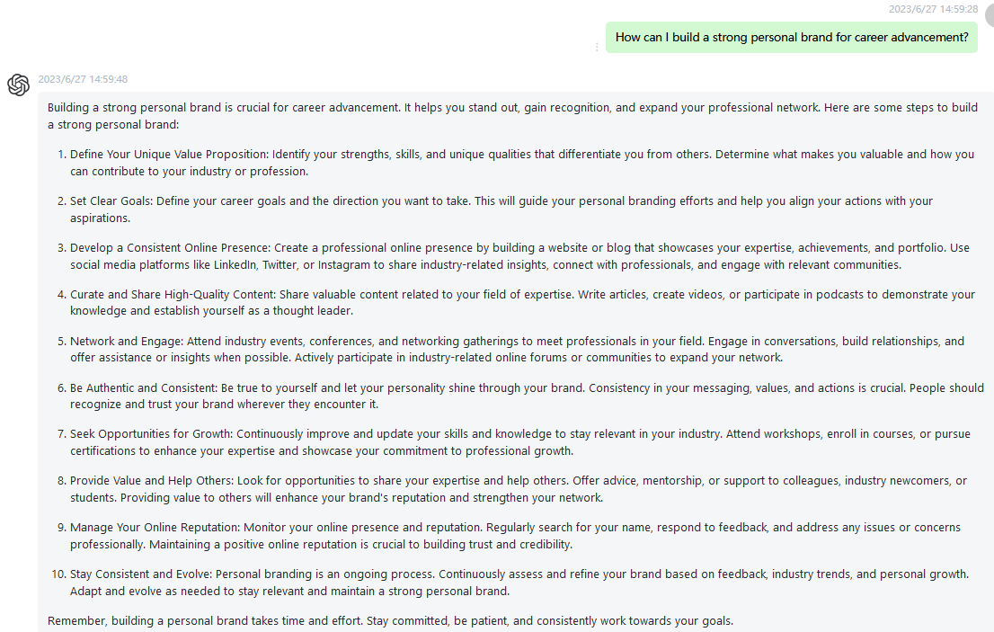

58 What are the latest advancements in technology and their potential impact on society? Please highlight the important words to the semantic meanings in every sentence using boldface fonts.

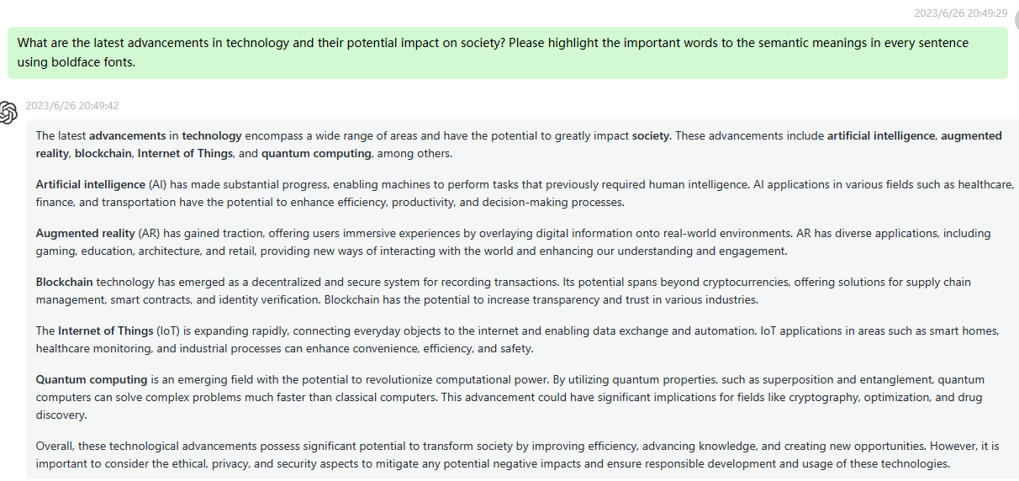

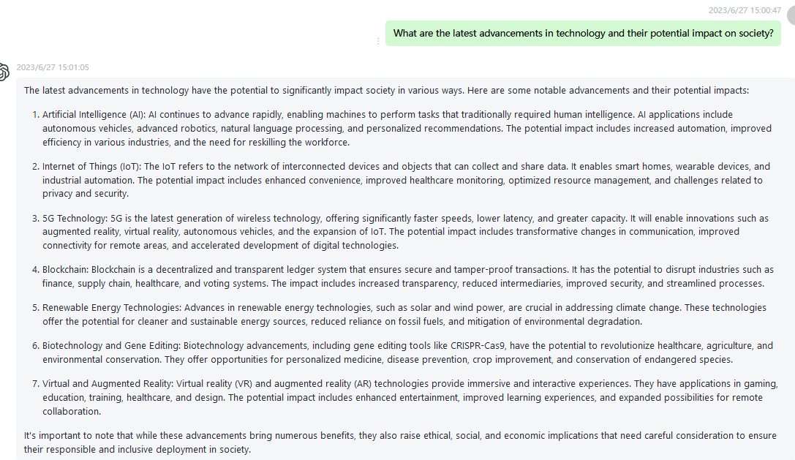

59 How can I improve my critical thinking skills and make better decisions? Please highlight the important words to the semantic meanings in every sentence using boldface fonts.

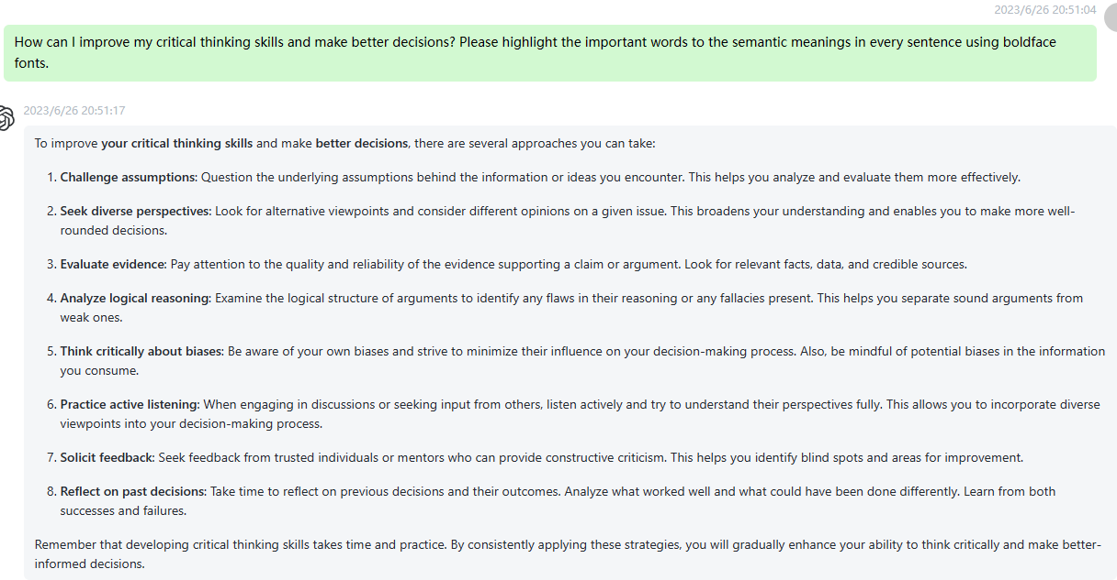

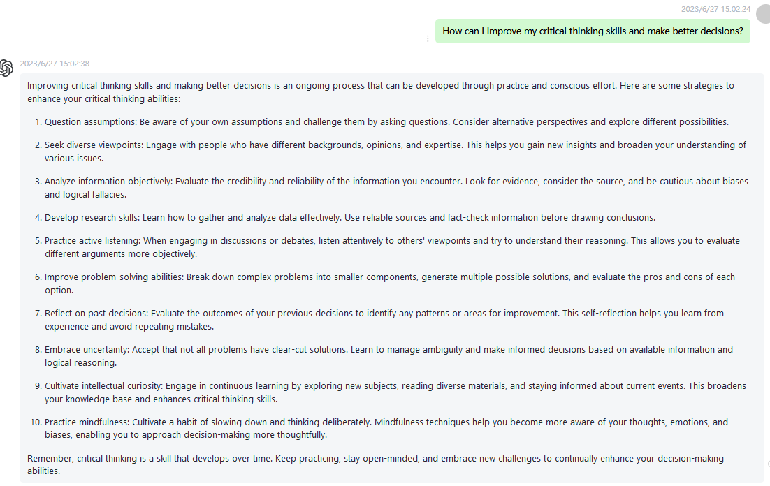

60 What are some effective techniques for public speaking and overcoming stage fright? Please highlight the important words to the semantic meanings in every sentence using boldface fonts.

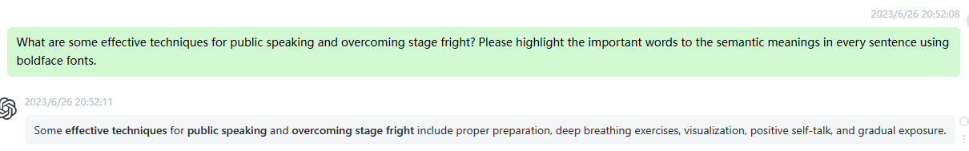

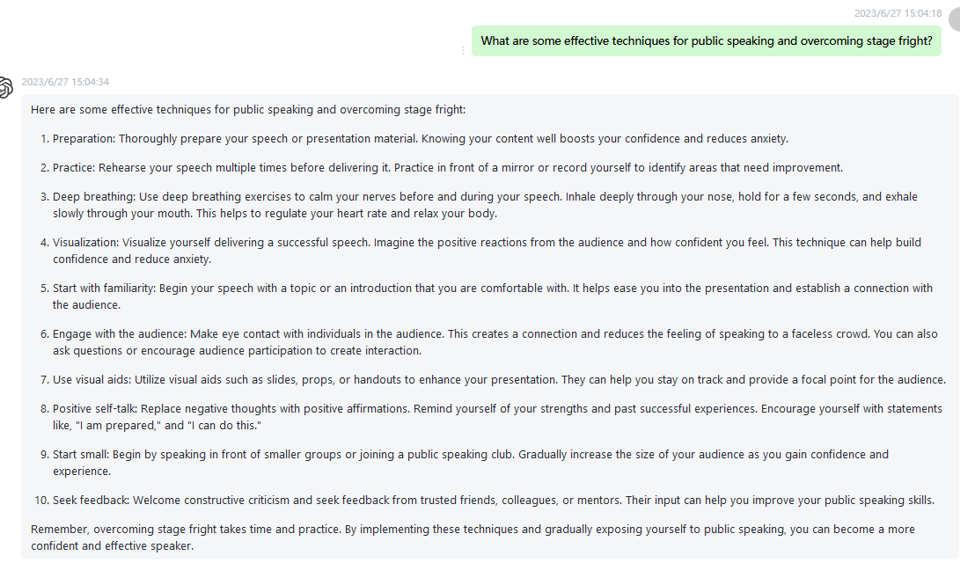

61 How can I develop resilience and bounce back from failures or setbacks? Please highlight the important words to the semantic meanings in every sentence using boldface fonts.

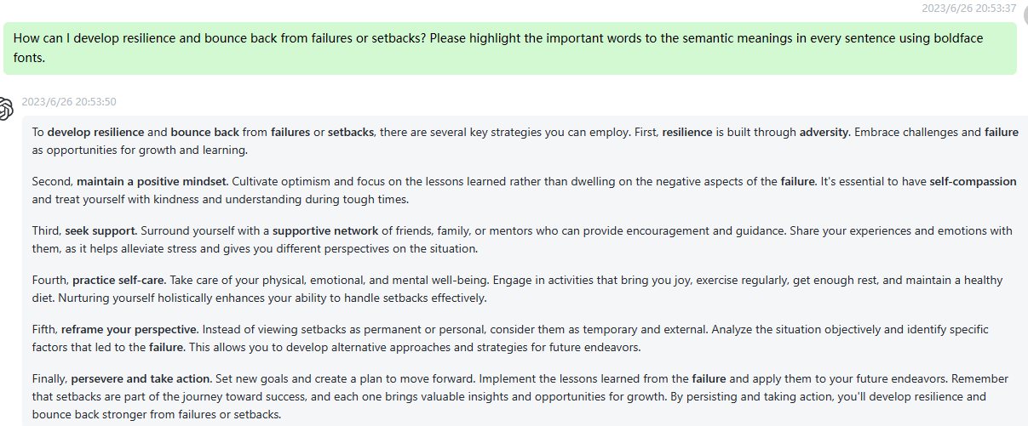

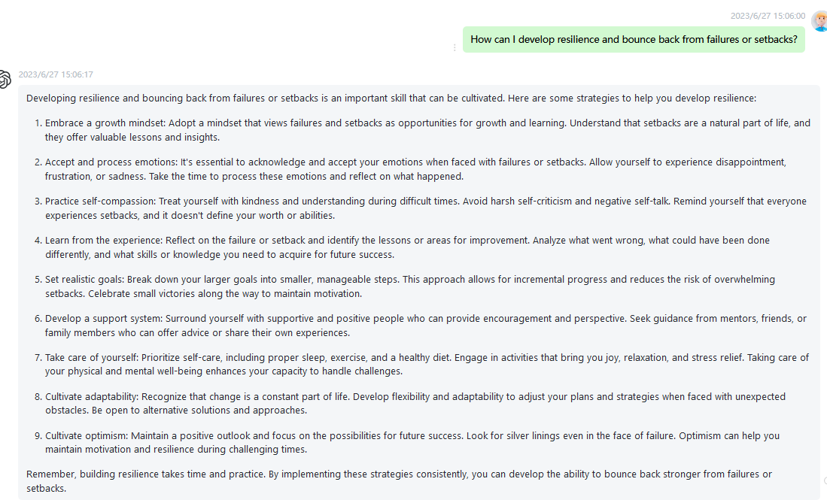

62 What are the best practices for effective teamwork and collaboration? Please highlight the important words to the semantic meanings in every sentence using boldface fonts.

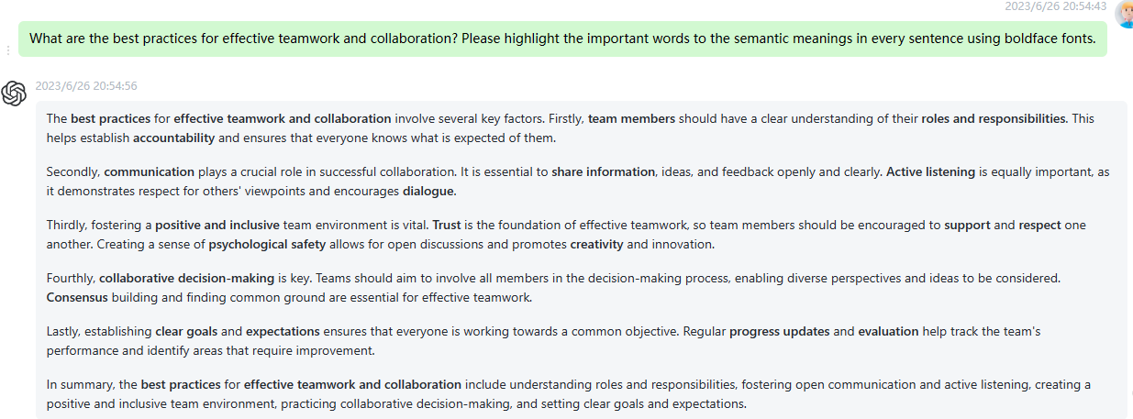

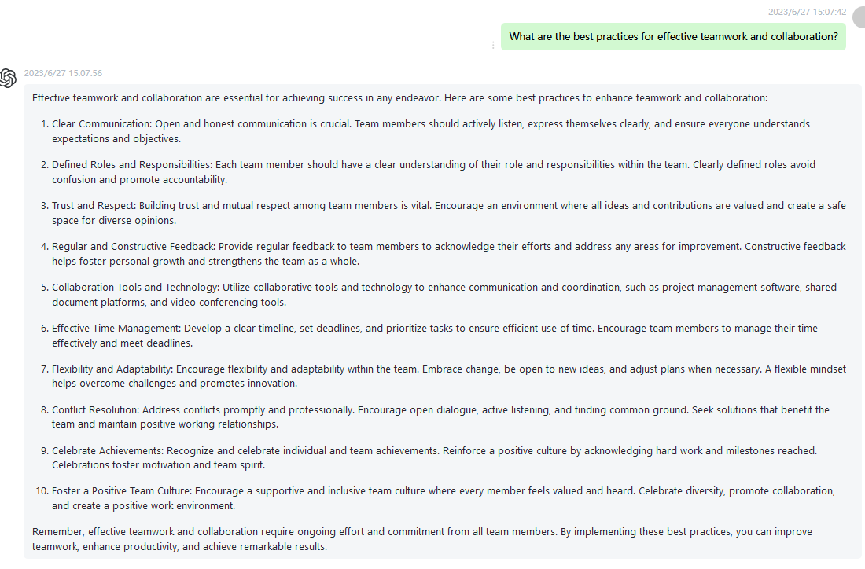

63 How can I stay motivated and overcome procrastination? Please highlight the important words to the semantic meanings in every sentence using boldface fonts.

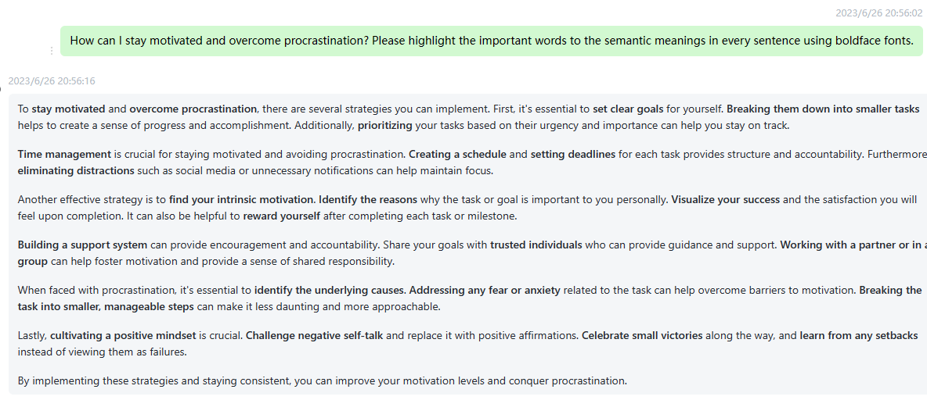

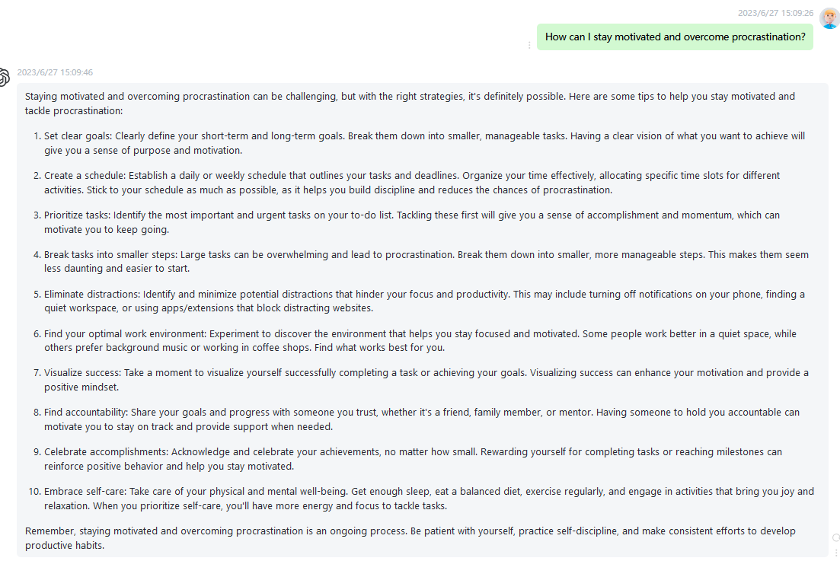

64 What are the emerging job trends and skills needed for future employment? Please highlight the important words to the semantic meanings in every sentence using boldface fonts.

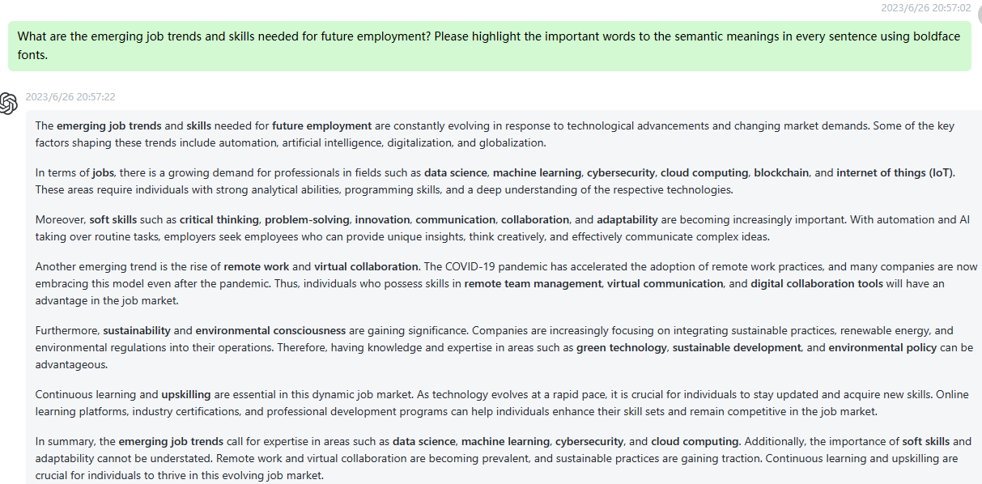

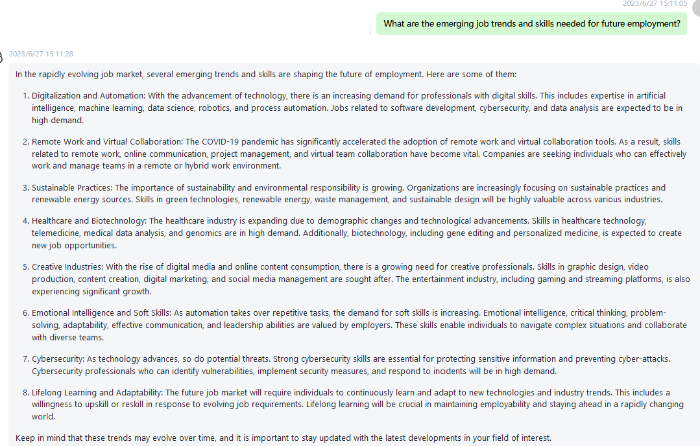

65 How can I effectively manage and resolve conflicts in a multicultural workplace? Please highlight the important words to the semantic meanings in every sentence using boldface fonts.

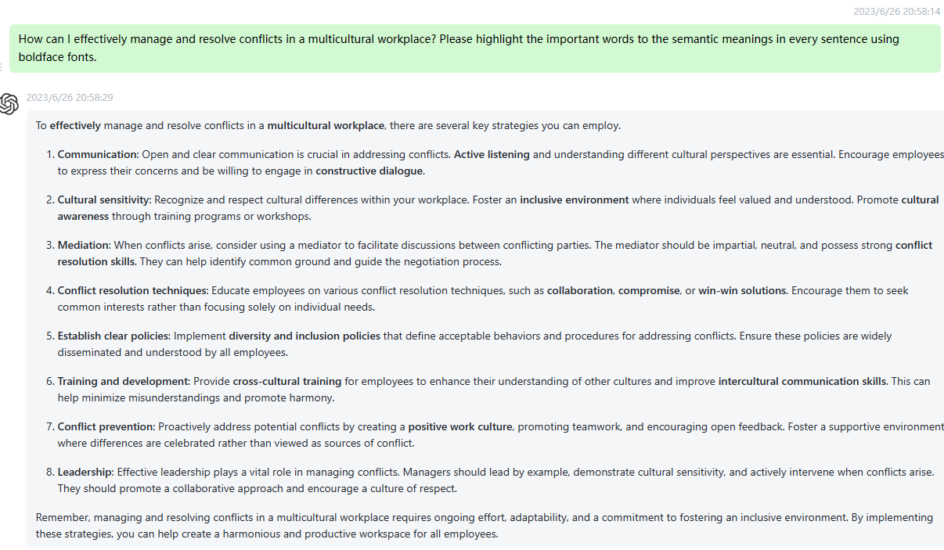

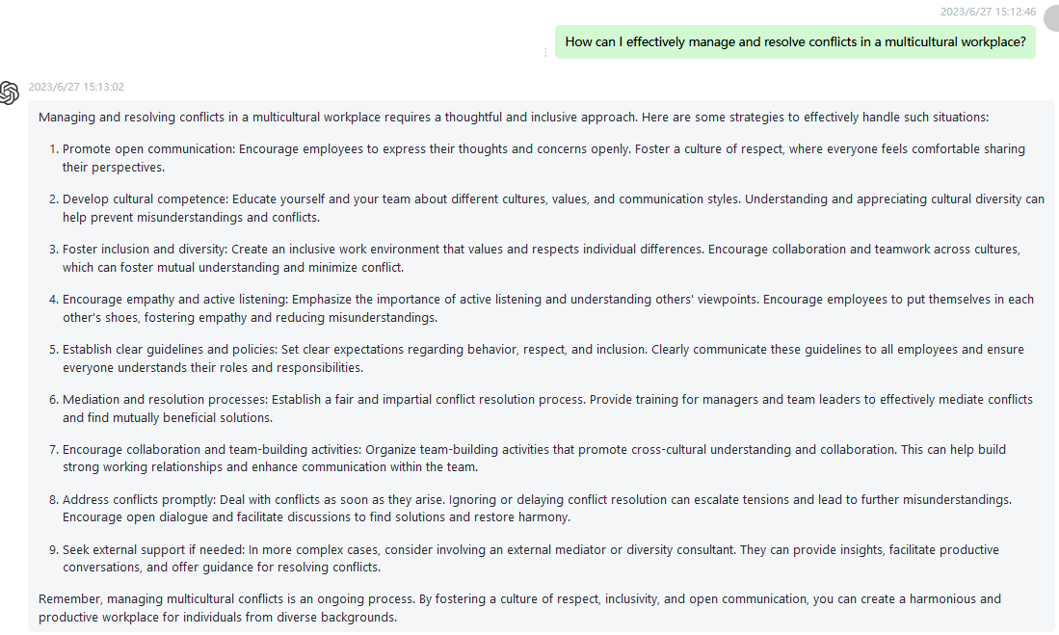

66 What are the principles of effective leadership and how can I apply them in my role? Please highlight the important words to the semantic meanings in every sentence using boldface fonts.

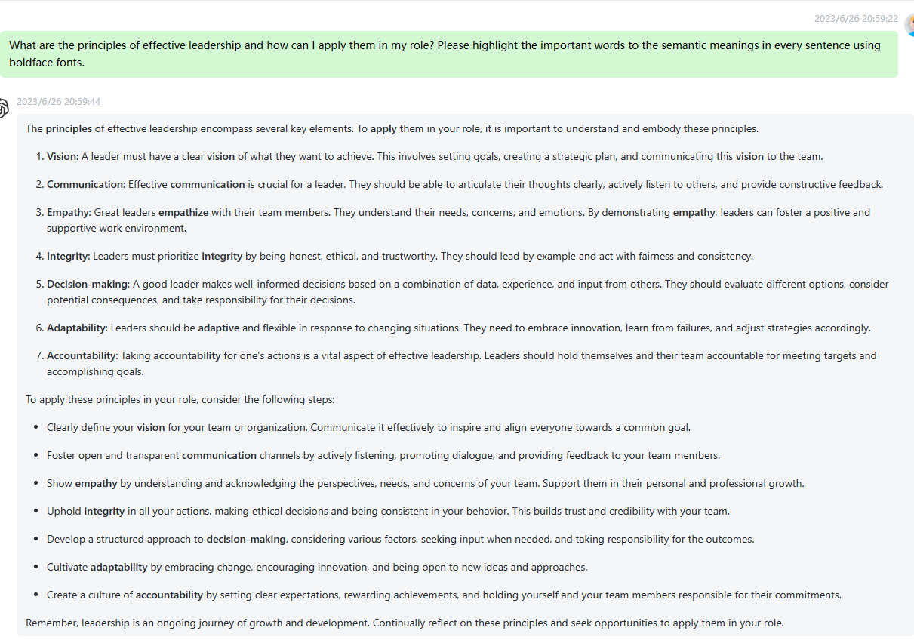

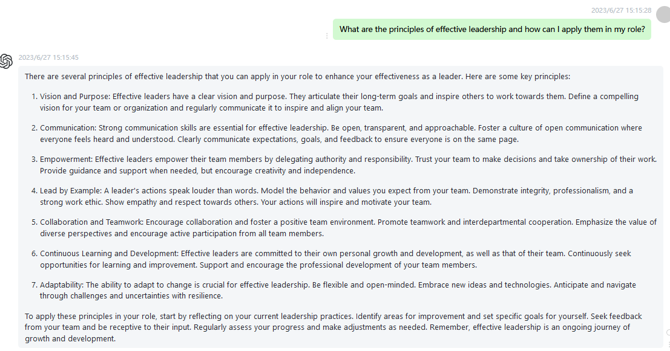

67 How can I cultivate a positive and inclusive work environment? Please highlight the important words to the semantic meanings in every sentence using boldface fonts.

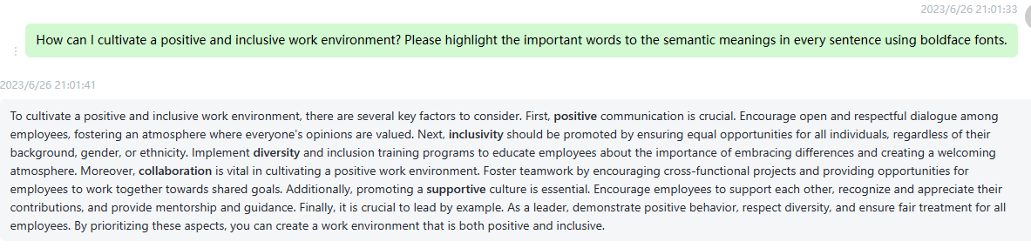

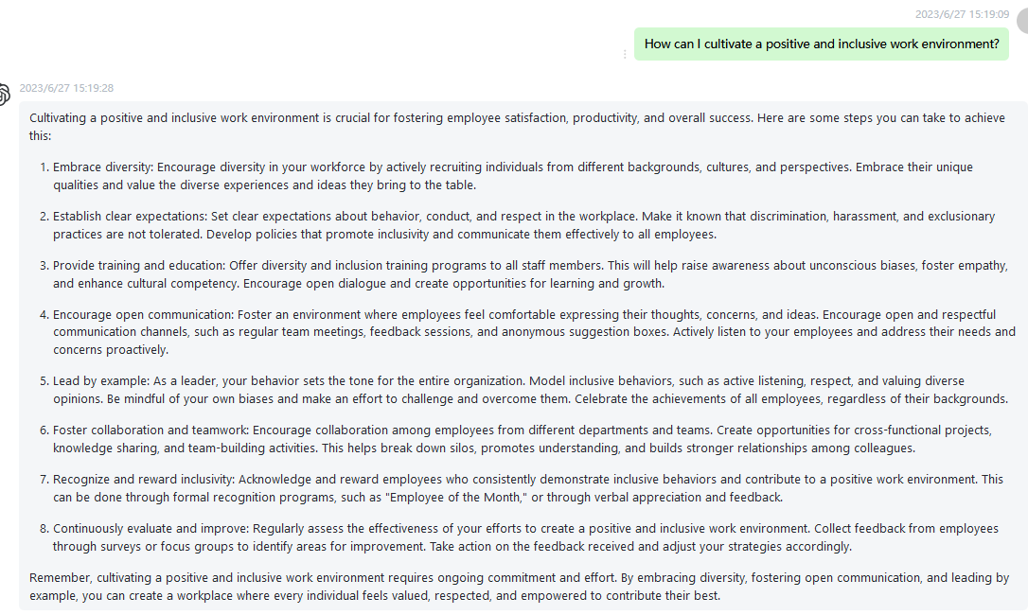

68 What are the key considerations for successful project management? Please highlight the important words to the semantic meanings in every sentence using boldface fonts.

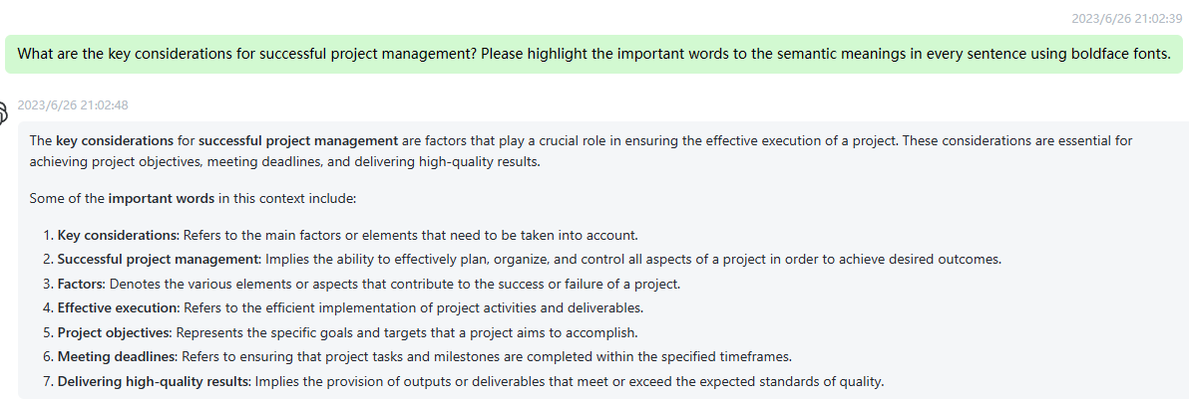

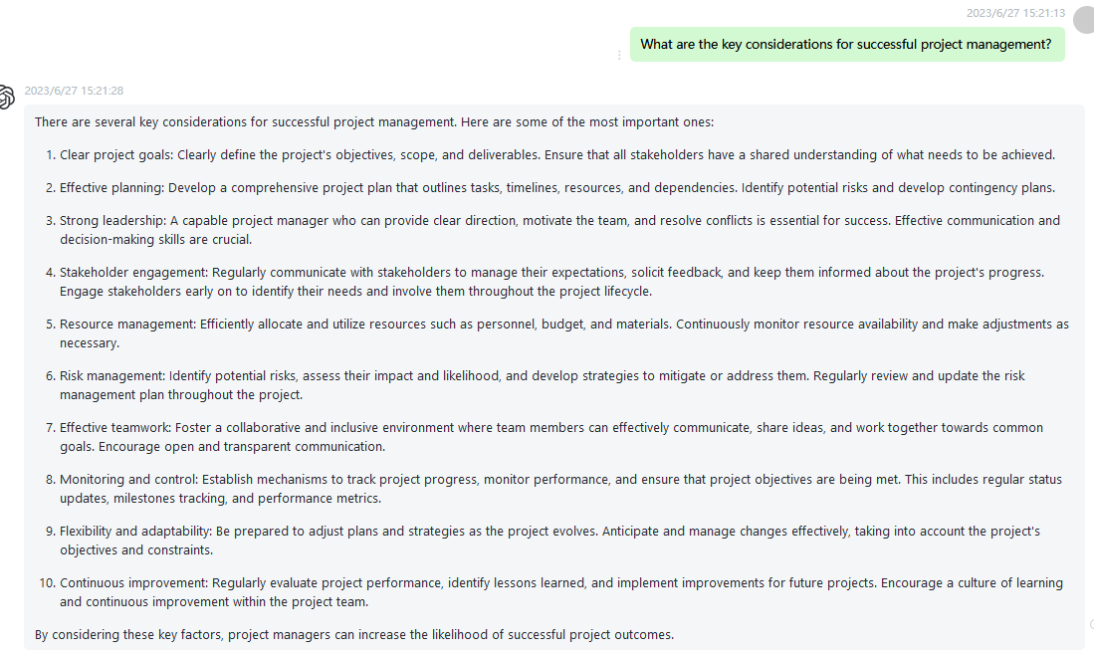

69 How can I build strong networking skills and expand my professional connections? Please highlight the important words to the semantic meanings in every sentence using boldface fonts.

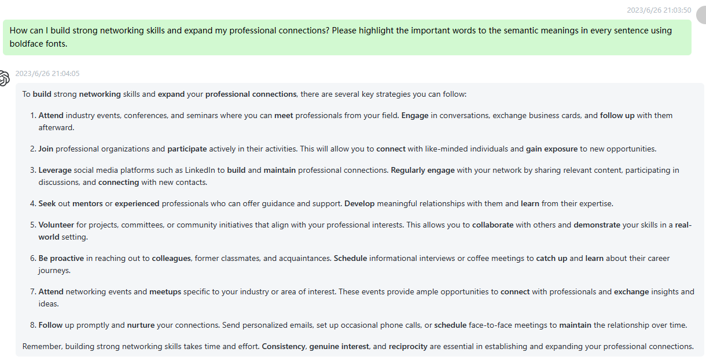

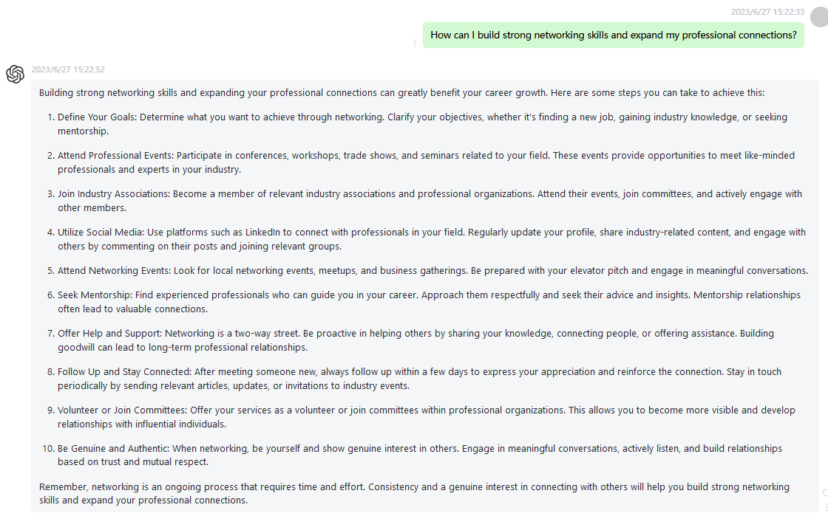

70 What are the challenges and opportunities in the field of sustainable development? Please highlight the important words to the semantic meanings in every sentence using boldface fonts.

